Giving Communication the High 5 – Implementing strategies to support and develop language in the early years

By Emma Hamilton

Language, learning and living go hand in hand and being able to communicate influences everything we do.
Building the Ambition
Abstract:
Language and communication skills are essential for young children to develop in order to make progress socially, emotionally and intellectually. An estimated 10% of children have long term speech, language and communication difficulties. In areas of deprivation, over 50% of children start school with delayed communication skills, although given the right support and intervention in the early years many children can catch up. The impact of language and communication difficulties can be life-long and severe: at least 60% of young offenders have communication difficulties. To support early years officers, teachers and parents in effectively developing language in the early years, Fife Speech and Language Therapists devised the Communication High 5. These are 5 simple strategies that all adults working with children can use in order to promote and support language development: face to face, thinking time, questions into comments, wow words and signs, symbols, objects. This research project was designed to evaluate the effectiveness of these strategies in supporting and improving language development of children in two nurseries in north east Fife. Language development is difficult to measure accurately; many different factors contribute to language development including home environment, innate intellectual ability and quality interactions, and each child follows their own individual trajectory of language progression. I used a combination of quantitative and qualitative data to attempt to reflect and capture the fluid, multi-faceted development of language, including discussions with colleagues, parent survey, parent focus group, a nursery environment audit, a language observation tool and the Renfrew Word Finding Vocabulary Test. The results showed that most children are developing language successfully, with many above average for their age, and showed that both the home and nursery environments are positively contributing to this. Although it was difficult to measure definitively to what extent the Communication High 5 strategies contributed to the language development of the children, they are a cost-effective, simple way to highlight the importance of early language development to all early years staff and parents. Giving language and communication prominence in the early years is an effective way to begin to narrow the poverty-related attainment gap and ensure that all children achieve their potential. The Communication High 5 strategies are a useful tool in achieving this.
Introduction
The importance of early language acquisition cannot be overestimated, being a crucial foundation for social, emotional and intellectual development. Most researchers now believe that although children, to some extent, have an innate ability to learn language, their environment and social interactions are also essential building blocks of language development. Ideally, when starting Primary 1, a child should be able to speak in proper sentences; ask lots of why questions; speak to and be understood by new adults; describe events in the past and future; and use most everyday words that adults use. However, many children are starting school in Scotland unable to communicate at this level. The Early Years Framework and Getting it Right for Every Child highlight the importance of early intervention, and of professionals working collaboratively to effectively support the child. In line with these documents, Fife Council, in partnership with NHS Fife Speech and Language Therapy (SALT), identified early language and communication as an area of focus and development for early years staff. SALT has highlighted five key strategies, the Communication High 5 (face to face; thinking time; questions into comments; wow words; and signs/symbols/objects) for staff to target in order to support early language skills. As a peripatetic nursery teacher in North East Fife, I plan to carry out an action research project to determine if using the Communication High 5 strategies can have a positive impact on language development in nursery children, and to what extent staff and parents find these strategies helpful.

Background: The Policy Context and Review of the Literature
Recent Scottish Government national policy and guidance has focused on early intervention and a drive for continual improvement, in order to fulfil ambitions for Scotland to be the best country in the world to grow up in. Despite this focus on early intervention, a significant number of Scottish children are failing to reach expected levels of language and communication development. At Scottish children’s 27-30 Month Review, speech, language and communication were the most common areas of concern. In Fife in 2016/17, 12.6% of children had a concern flagged in these specific areas. The poverty-related attainment gap is also evident at the 27-30 Month Review; 17.5% of children from the most deprived areas had a speech, language and communication concern, compared with 7.6% within the least deprived areas. The Save the Children Report, Ready to Read, succinctly identifies how we can begin to narrow the poverty related attainment gap: “ensuring that all children are reading well by the age of 11 would make a game-changing contribution to making us a fairer country...this can only be achieved if we commit to boosting the early language skills of our poorest children.”
The implications of early language difficulties can extend beyond poor educational attainment, with serious, lifelong consequences. A longitudinal study following over 17,000 UK children from school entry to adulthood found a strong association between vocabulary difficulties at age 5 and poor literacy, mental health and employment outcomes at age 34. Similarly, a literature review of communication support needs commissioned by the Scottish Government found that people with speech, language and communication needs (SLCN) were more likely to live in an area of social deprivation, be unemployed or employed at a lower than expected level, and/or be victims of crime or convicted of a crime. 75% of young offenders in the UK have poor communication skills, with around 30% having a diagnosed SLCN. With these sobering statistics in mind, it is clear to see why effectively supporting early language development should be a key priority in Scottish education.
Building the Ambition contains many references to language development and effective ways to support this. In terms of developing vocabulary, it recommends that adults "model new words and phrases with just enough challenge to take the child forward”. The importance of thinking time is also highlighted prominently: ”give time for the child to find the words and gestures to explain their meaning“ and ”time to talk in a supportive, unhurried way with a key adult“. Commenting as an alternative to questioning is also suggested as an effective strategy: ”Describe to the child what they are thinking and doing and encourage the child to do the same.” This document fits neatly with the Communication High 5 strategies of ’wow words’, ’thinking time‘ and ’questions into comments’, highlighting their value in supporting language development.
To commence a literature review, I conducted a search using Education Source – EBSCO. The search term ‘early language development’ returned 261 hits. As my action research focuses on typically developing children, I excluded articles on deaf, bilingual and ASD children, leaving 59 articles. Although difficult to find research specifically relating to the Communication High 5 strategies within these articles, I did find research relevant to inform my thinking and practice.
Riley et al conducted a small-scale study in response to the concerns of two inner city primary school head teachers that children were entering primary school with poorly- developed communication skills, leading to difficulties in accessing the curriculum. The researchers planned an intervention involving greater opportunities for extended talk, collaborative talk, encouragement from adults and relevant contexts for talk. Their results showed positive gains in oral language skills. Although a limitation of this study is the small number of schools involved, it is a good example of the positive effect that planned opportunities for talking in small groups can have.
Dockrell et al found through observations of different nursery settings that although there were many opportunities for oral language activities, few children chose to access them. They also discovered few opportunities for children to engage in small group tasks, which are important for developing oral language skills. In 2010 Dockrell et al found that much of the talk in pre-school settings was dominated by teachers, and often limited to directives and behaviour management, rather than being responsive to the interests of the children, expanding on their ideas or introducing new vocabulary. This research suggests that if we want to effectively support children to develop their language and communication skills, we need to focus on frequently involving children in small group activities and ensuring that adult language is used to comment, ponder, introduce new vocabulary and model, rather than directing and managing.
Rowe’s research on wait time found that teachers typically wait less than one second after asking a question for children to reply. By increasing wait time to between three and five seconds, numerous benefits were noted, including more correct answers, longer answers, more responses from lower ability children and an increase in children’s own questions. Increasing thinking time, giving children longer to consider the question’s meaning and form a response, should improve the quality of their answer. Importantly, this also shows children that the adult is genuinely listening to and interested in their answer as they wait for a response, rather than interrupting the thinking time with an additional question or prompt, which may muddle the young child.
Data from Fisher’s Oxfordshire ACI project strongly supports the usefulness of the strategy ’questions into comments’. They found that most questions asked in nurseries were made by adults, the main purposes being to check children’s knowledge and understanding, or as a behaviour technique to maintain control when working with a group of children. Yet these questions served to interrupt children’s learning and thinking, dismiss their ideas and confuse them. Furthermore, asking questions can cause anxiety and pressurise some children by putting them on the spot, often leading to one-word answers. Fisher found that ”when we change from questions to statements, children talk to us for longer and ask more questions themselves”. Comments rather than questions have several advantages in terms of developing children’s communication skills and vocabulary. The adult commenting provides a model of good language use, where new vocabulary can be heard in context. It does not put pressure on the child to speak, and results in longer statements and more questions from the child. Despite the benefits of less questions and more comments, in practice it can be difficult for adults to achieve, as it is ingrained in us to think that asking questions is the most effective way to extend learning and teach children and therefore may be a difficult strategy to successfully employ.

Research Design
Language is a complex system, made up of five main components: phonemes, morphemes, lexemes, syntax and context. They work together with semantics, pragmatics and grammar to enable meaningful communication. There are numerous language assessment and screening tools available, some assessing only one component and others offering a broader assessment. To assess language accurately, it is important to measure comprehension, expressive language and pragmatics to get a complete picture of a child’s language abilities. Patterns of language development can also vary greatly between young children but still be within normal developmental parameters. For example, Fenson et al found expressive vocabulary sizes ranging from fewer than nine to over 198 words in typically-developing 16-month-old children, and from fewer than 41 to over 405 words in typically-developing 20-month-olds. This uneven pattern of language development, although perfectly normal, can make it problematic to correctly identify language delays or difficulties. Children’s language must therefore be monitored and measured at regular intervals throughout the early years, to ensure that problems are neither missed nor incorrectly identified.
The criteria that I used for selecting language assessments was that they had to be suitable for the nursery age group of 3-5 years old; quick and easy to administer; the scores easy to interpret; and the availability of the assessment, including its cost. It is also important that assessments are environmentally as natural as possible, to gain an accurate picture of the child’s language abilities without placing them in an unknown or stressful assessment situation. Taking these factors into account, I used a structured observation sheet and the Renfrew Word Finding Vocabulary Test. The observation sheet was adapted from The Age 4 Speech, Language and Communication Progression Tool developed by the communication charity I CAN. As this tool is designed to be used with 4-year olds, I only used it with the children who were 4 at nursery, a total of 31 children. The Renfrew Word Finding Vocabulary Test involved the children naming a series of pictures, to assess word-finding ability. It was quick to administer and straightforward to score and interpret the results. I used this assessment twice over an eight-week period to measure if using the Communication High 5 strategies had a positive effect on language development. Although vocabulary is only one aspect of language, there is a correlation between vocabulary and reading ability, with vocabulary ability at age 5 being strongly linked to reading ability at age 7. A child with below-average vocabulary at age 5 will be much less likely to score highly in a test of their comprehension skills at age 11 than a child with above-average vocabulary at age 5. ‘The Oxford Language Report’ affirms the usefulness of measuring vocabulary: ”Vocabulary is a huge predictor of how far children from any background will succeed at school and beyond.”
In addition to the quantitative data, I also gathered qualitative data through staff and parent surveys, a parent focus group and a communication environment audit, adapted from the Communication Supporting Classroom Observation Tool. Language development is a dynamic, non-linear process, and I recognise the difficulties in identifying what factors are responsible for supporting and improving aspects of language development. How can we know that it is interaction within the nursery environment that is enabling children to develop their language successfully, rather than innate ability, home environment or parental support? By gathering quantitative data, I hoped to identify common themes and begin to unpick what strategies could be making a difference to early language development.
54 children participated in this research. The parents and carers of these children (52 due to two sets of siblings) were given a written survey to complete, with 32 out of 52 returned, a response of approximately 60%. The parents and carers were also invited to participate in a focus group discussion about early language development, with four parents attending.
There was no control group in this research project, as it was not possible either practically or ethically to withhold the Communication High 5 strategies from a specific group of children. Regarding issues of ethics, I informed parents and carers of the purpose and methods of my research. Confidentiality has been maintained, with each child referred to by a number, and any identifying features of participants removed from the results and analysis.

Findings and Analysis
I started my research by carrying out a communication environment audit at both nursery settings (Table 1). These showed that both nurseries are, to a large extent, providing high quality environments for supporting and developing language and communication, but also highlighted several areas that could be improved- namely the use of visuals and signing, and increased opportunities for children to work as part of small groups.
Table 1
Communication Environment Audit
Setting: A Date: February 2019
Language Learning Environment
 | Not seen | Observed | Comments
Learning areas are clearly labelled with pictures/words |  | X | Boardmaker symbols and words
Quiet area(s) for children to retreat to or use for small group activities |  | X | Both inside and outside
Book area with an appropriate range of books – fiction, non-fiction, different cultures and languages, relevant to the children’s interests |  | X | But not many books focusing on different cultures and languages
Non-fiction books and books on specific topics available in different areas of the nursery |  | X
Background noise managed effectively to ensure adults and children can hear each other with ease |  | X
There is good natural light |  | X
Resources are clearly labelled with pictures/words for children to access independently | X |  | Not always labelled
Good quality toys, small world objects and real/natural resources are all available |  | X | Rich core provision
Musical instruments/noise makers available |  | X
Role play area is available |  | X

Language Learning Opportunities
 | Not seen | Observed | Comments
Opportunities for small group work, facilitated by an adult |  | X | But not very frequently
Opportunities for interactive book reading, facilitated by an adult |  | X | Daily
Opportunities for conversations with adults |  | X
Opportunities for conversations with peers |  | X
Rhymes and songs |  | X

Language Learning Interactions
 | Not seen | Observed | Comments
Face to face – adults get down to the child’s level when interacting with them |  | X
Natural gestures and key word signing are used by adults in interactions with children |  | X | Signalong used. Staff training on signalong would be useful to upskill staff and develop confidence
Adults use pictures, symbols and props to reinforce language | X |  | Introduce Boardmaker symbols – make set of useful cards for each staff member to add to their lanyard
Thinking time – adults give children time to think during interactions and plenty of time to respond |  | X
Questions into comments – adult uses lots of commenting and pondering to provide a good model of language and avoid putting pressure on child to speak by asking lots of questions |  | X
Adults praise listening skills |  | X
Adult introduces new vocabulary to children (wow words) and repeats them frequently throughout the day in context |  | X

Setting: B Date: February 2019

Language Learning Environment
 | Not seen | Observed | Comments
Learning areas are clearly labelled with pictures/words |  | X | Pictures and words
Quiet area(s) for children to retreat to or use for small group activities |  | X | Inside and outside
Book area with an appropriate range of books – fiction, non-fiction, different cultures and languages, relevant to the children’s interests |  | X | Books are regularly changed to reflect interests  Need to add dual-language
Non-fiction books and books on specific topics available in different areas of the nursery |  | X
Background noise managed effectively to ensure adults and children can hear each other with ease |  | X
There is good natural light |  | X
Resources are clearly labelled with pictures/words for children to access independently |  | X | Easily accessible for children
Good quality toys, small world objects and real/natural resources are all available |  | X
Musical instruments/noise makers available |  | X
Role play area is available |  | X

Language Learning Opportunities
 | Not seen | Observed | Comments
Opportunities for small group work, facilitated by an adult |  | X
Opportunities for interactive book reading, facilitated by an adult |  | X | Frequently
Opportunities for conversations with adults |  | X
Opportunities for conversations with peers |  | X
Rhymes and songs |  | X

Language Learning Interactions
 | Not seen | Observed | Comments
Face to face – adults get down to the child’s level when interacting with them |  | X
Natural gestures and key word signing are used by adults in interactions with children |  | X | Signalong used by some staff members – more training on this would be beneficial to ensure consistency and develop staff confidence
Adults use pictures, symbols and props to reinforce language |  | X | Boardmaker symbols used
Thinking time – adults give children time to think during interactions and plenty of time to respond |  | X
Questions into comments – adult uses lots of commenting and pondering to provide a good model of language and avoid putting pressure on child to speak by asking lots of questions |  | X
Adults praise listening skills |  | X
Adult introduces new vocabulary to children (wow words) and repeats them frequently throughout the day in context |  | X | ‘Wow words’ wall display regularly added to

Although lack of staff training in early language and communication is a common problem, this is not an issue for staff in these nurseries. We are in a fortunate position in Fife as most early years staff have received training in language and communication this session, including the Communication High 5 strategies. Through discussion and observations, I found that staff feel confident in supporting children in developing their language and are skilled in identifying difficulties. The challenge now is to maintain this high level of staff training and confidence, particularly when new staff members join, in order to achieve consistency and persistency in implementing the Communication High 5 strategies universally.
As the home environment and parental interactions are the biggest influences on a child’s language development, it was important to consider this in my research. A child who starts school with a strong grasp of language will find it easier to develop reading and writing skills, which then facilitates progress across all curricular areas. To form a picture of home language environments, a written survey was given to each child's parent or carer, with a return rate of 32 out of 52, around 60%.
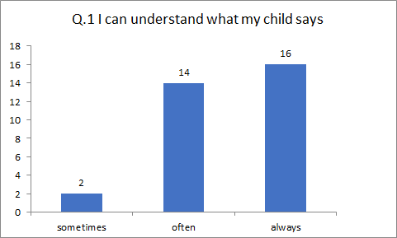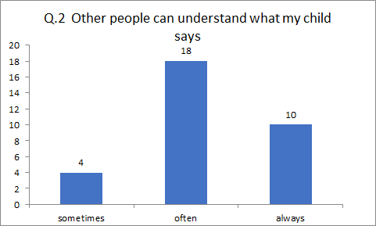
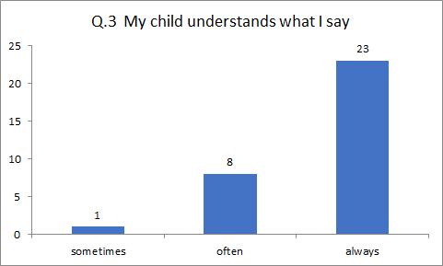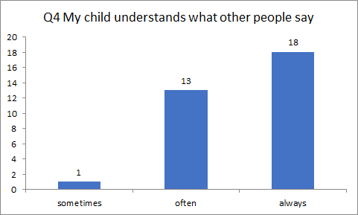
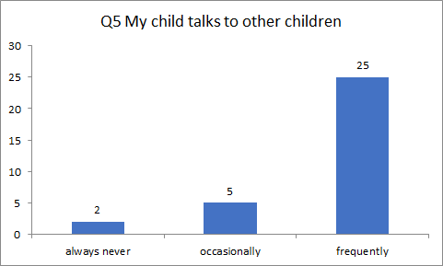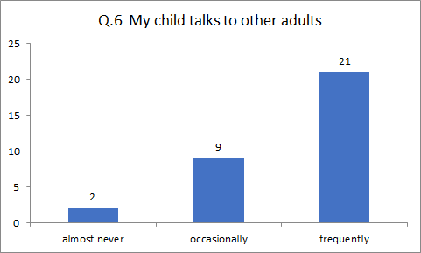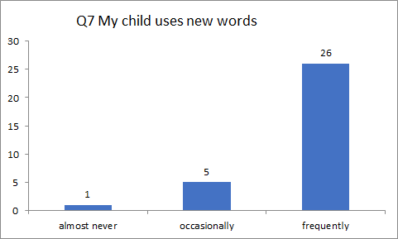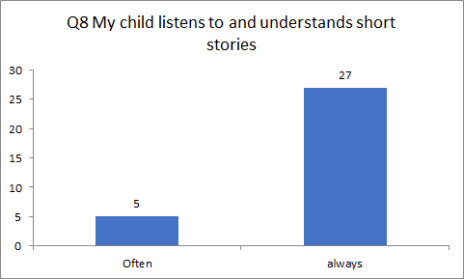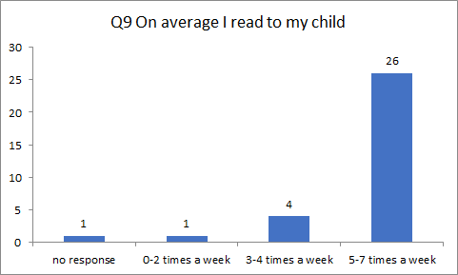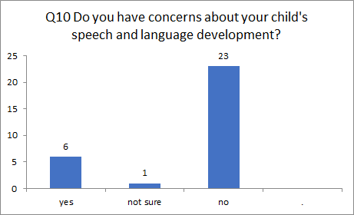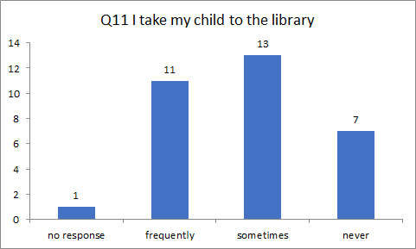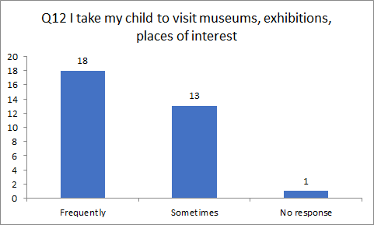
The results were largely positive: 72% said their child always understands what they say; 78% responded that their child frequently talks to other children; and 81% felt that their child frequently uses new words. Quality home environments for language development refers not only to the quantity of spoken words heard by the children, but also includes engaging activities such as listening to stories, visiting places of interests like libraries, museums and parks, quality toys and parental limiting of screen time. The survey results suggest that most children are experiencing a quality home environment, with 81% of parents or carers reading to their child 5-7 times a week, and 56% of respondents frequently taking their children to places of interest, museums and exhibitions. Interestingly, responses to the question on frequency of visits to the library were more mixed: 34% said frequently, 41% said sometimes and 22% said never. These results, however, are significantly better than a 2007 study that found 55% of three-year-olds in Scotland have never visited their local library, with only 18% visiting frequently.
To gain a deeper understanding of home environments, I then invited parents and carers to attend a focus group; four parents participated in this. I began by asking how they support language development at home. All four parents reported reading to their child frequently at home, ranging from several times a day to most days, and regularly visiting the library and other local places of interest. For the next task I asked parents if they could rate the SHANARRI indicators, plus ‘language and communication’ from 1-8 in order of importance, with 1 being the most important. Two parents rated ‘language and communication’ third, one rated it fourth and one rated it fifth. One parent noted that she felt ‘language and communication’ could be encompassed in the ‘included’ indicator, which led to a discussion around how it becomes difficult to achieve several indicators without ‘language and communication’ being developed to some extent, most notably ‘included’ and ‘achieving’. The focus group ended with a discussion around the Communication High 5 strategies. Parents felt them useful and described using them successfully in the home environment. They suggested that a potential barrier to using the strategy of sign, symbols and objects at home is lack of resources; most parents will not have access to Boardmaker signs. One parent suggested that nursery staff could create several packs of signs that parents can borrow to use at home; for example, signs for toilet routines. Data from the parent and carer surveys and focus group shows that, in general, the children are experiencing supportive and encouraging home language environments, which will have a positive impact on their language development.
To measure children’s language development, I used the Speech, Language and Communication Progression Tool Age 4 with the 4-year-old nursery children (Table 2). This tool involves observing children in their play and scoring them on their understanding of spoken language, understanding and using vocabulary, using sentences, storytelling and narrative, speech and social interaction. Each area is scored out of 15, with scores graded into three colours: 13-15 are green, showing children are making very good progress; 6-12 are orange, showing children are making progress but may benefit from some extra support; and 0-5 are red, indicating that children are making slow progress and require additional, targeted support. Covering all aspects of language development, this tool should provide a holistic picture of each child’s development in speech, language and communication.
Table 2
Speech, Language and Communication Progression Tool Age 4 Results
Setting A  Child | Understanding Spoken language | Understanding and using vocabulary | Using Sentences | Storytelling and narrative | Speech | Social interaction
1 | 15 | 15 | 15 | 13 | 9 | 15
2 | 15 | 15 | 15 | 13 | 13 | 13
3 | 15 | 15 | 15 | 13 | 13 | 9
4 | 15 | 15 | 15 | 11 | 13 | 11
5 | 11 | 13 | 15 | 11 | 11 | 13
6 | 15 | 15 | 15 | 13 | 15 | 13
7 | 15 | 15 | 15 | 13 | 15 | 15
8 | 15 | 15 | 15 | 13 | 15 | 13
9 | 15 | 15 | 15 | 15 | 15 | 13
10 | 11 | 13 | 15 | 11 | 11 | 9
11 | 5 | 7 | 13 | 9 | 8 | 3
12 | 5 | 7 | 11 | 7 | 8 | 3
13 | 13 | 15 | 15 | 13 | 13 | 13
14 | 15 | 15 | 15 | 13 | 13 | 13
15 | 15 | 15 | 15 | 15 | 15 | 15
16 | 15 | 15 | 15 | 13 | 13 | 11
17 | 13 | 15 | 15 | 11 | 13 | 13

Setting B  Child | UnderstandingSpoken language | Understanding and using vocabulary | Using Sentences | Storytelling and narrative | Speech | Social interaction
1 | 9 | 13 | 13 | 7 | 9 | 7
2 | 13 | 13 | 15 | 11 | 11 | 13
3 | 15 | 15 | 15 | 13 | 13 | 13
4 | 15 | 15 | 15 | 13 | 13 | 13
5 | 15 | 15 | 15 | 13 | 13 | 13
6 | 9 | 9 | 13 | 9 | 9 | 13
7 | 9 | 13 | 13 | 9 | 11 | 11
8 | 9 | 9 | 13 | 7 | 11 | 15
9 | 11 | 9 | 13 | 9 | 11 | 13
10 | 11 | 15 | 13 | 9 | 13 | 9
11 | 9 | 5 | 11 | 3 | 3 | 11
12 | 9 | 9 | 13 | 9 | 13 | 9
13 | 13 | 15 | 13 | 11 | 13 | 15
14 | 15 | 15 | 15 | 13 | 13 | 15

Key
Score
13-15 | Making very good progress
6-12 | Making steady progress with some support required
0-5 | Making slow progress and requiring targeted support

The results show that many children are making good progress in speech, language and communication development: 55% scored green in their understanding of spoken language; 77% scored green in understanding and using vocabulary; and 94% scored green in their use of sentences. Storytelling and narrative skills showed a more mixed picture, with around 52% scoring orange, indicating that they need some support in this area. Speech is similar, with 39% in the orange zone. 58% scored green in social interaction. Only three children had one or more red scores, indicating that they are behind in their language development and need targeted, individual support. Overall these results are positive and show that most children are developing speech, language and communication skills at a good rate. Children are especially proficient at speaking in sentences, and understanding and using vocabulary, which relate to the Communication High 5 strategies of wow words and questions into comments. Storytelling and narrative skills stand out as areas for development; therefore, it would be useful to consider how opportunities for these skills can be built into each nursery setting.
The Renfrew Word Finding Vocabulary Test was used with 54 children in two nurseries. I carried out an initial assessment in March 2019 and completed a follow-up assessment in May 2019, approximately ten weeks later. The full results are detailed in Appendix 1 and difference in age equivalent scores in months is shown in the graphs below.
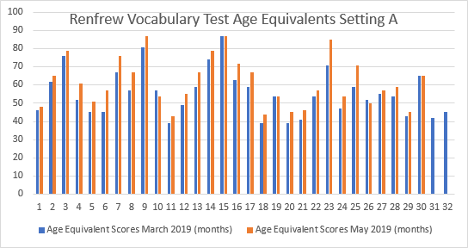
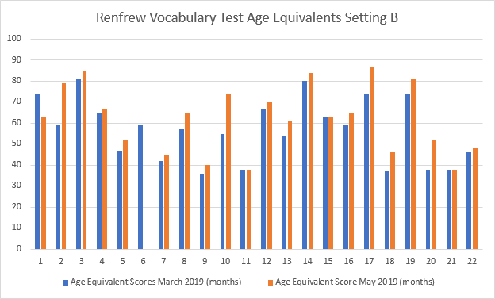
The results for setting A show that of 32 children, 25 increased their age equivalent scores between March and May, three scored the same, and two had lower scores in May than in March. In setting B, of 22 children, three remained the same, one decreased their score, and the rest all increased their age equivalent score. Scores in setting A increased by an average of three months between March and May, and in setting B by an average of 5.3 months. Overall, the biggest increase in score was 20 months and the biggest decrease was 11 months. Three children were absent during the test in May so no data for the second test is available for them. The fact that 78% of the children increased their age equivalent scores is promising, although from the available data it is not possible to attribute this to the Communication High 5 strategies alone; it is probable that home environment and natural development of language skills contributed to this to some extent. Three children, or 6%, scored lower in the May test. This does not necessarily indicate their language skills are regressing but could be explained by factors such as lack of concentration, poor motivation or distractions during the test. The results should therefore be interpreted with care and viewed in conjunction alongside additional assessment data. For example; a difference in score of only two or three points can result in a difference in age equivalent scores of several months.
I compared the vocabulary test results to the Scottish Index of Multiple Deprivation (SIMD) decile data to see if there was any correlation between lower results and living in an area of greater deprivation; a poverty-related attainment gap. In setting A, one child in decile 6 had an age equivalent score 1 year and 1 month lower than their actual age, yet another child in decile 6 was 10 months ahead in their age equivalent score. One decile 10 child scored 1 year 10 months lower than their actual age. Similarly, in setting B, a decile 5 child scored 1 year and 7 months ahead of their age, whilst a decile 10 child was 9 months below their actual age. These results do not show a clear link between living in a less affluent area and achieving lower vocabulary scores. It is possible that this is because none of the children in this study live in an area of significant deprivation.
There are several limitations in my research design. Firstly, there was no control group in this study, which makes it harder to identify specific factors, such as the Communication High 5 strategies, as directly contributing to language development. Without a control group, it is still possible to measure language developmental gains, but it is difficult to ascertain if that improvement is due to value added in nursery rather than natural development, innate ability or input from home environments.
A further limitation is time scale, with around ten weeks between carrying out each Renfrew Word Finding Vocabulary Test. In future, using the Renfrew vocabulary test several times throughout the academic year would give a more accurate picture over time, as all children follow a different path of language development, with much variation in pace. It is also important not to equate vocabulary scores with general language ability; for example, a child with a normal age equivalent vocabulary score might have difficulties with other aspects of language, such as pragmatics or receptive language. To accurately measure language ability and identify delays or impairments, various language measures should be used to create a holistic picture of a child’s language development over an extended period.
Taking the data from all of the above tests and audits as a whole, it shows the majority of children are developing language at an age-appropriate rate, with a number of children significantly above-average for their age. Both the home and nursery environment will certainly have contributed to language development, but it is impossible to isolate to what extent different factors such as parental interactions, quality experiences or Communication High 5 strategies have made a positive difference. However, there are several key benefits emerging from using the Communication High 5: it is relatively quick and inexpensive to train staff; they are a simple, clear and useful way to share strategies with parents; and they highlight the importance of early language development. Moving forward in terms of my own practice, I intend to develop further opportunities for children to participate in storytelling, work as part of a small group and make greater use of visuals and signing. Nationally, language and communication should be given greater prominence, especially in the early years. One possible way to achieve this is by including ‘Language’ as a wellbeing indicator, as part of SHANARRI. ’Achieving‘ and 'included‘ are difficult to fulfil without ’language and communication’. Another possibility is to provide more frequent, high quality staff development opportunities in language and communication, both as part of initial training and ongoing CPD. Lastly, several recent reports have highlighted the benefits of introducing a universal screening tool for language development in the early years. This would ensure that delays or difficulties are correctly identified and provide the opportunity for early intervention.

Conclusions
Despite my results showing the language development of most children as being at or above expected levels, it is difficult to identify to what extent the Communication High 5 strategies have contributed to this: home environment, nursery environment and innate ability all influence language development to some degree. Perhaps the greatest benefit of the Communication High 5 strategies is that they highlight the importance of language development in the early years - for staff and parents and carers - in a clear, accessible and cost-effective way. It is also straightforward to train staff in the use of these strategies and they can easily be shared with parents and carers.
Going forward, it is vital to provide regular staff training on early language development, as part of initial training and as CPD for qualified staff. Without an understanding of typical language development and language delays or difficulties, staff will lack the necessary skills to effectively support and promote language in the early years. Regular screening of language development throughout the early years is another area that could be developed, enabling accurate and, possibly, earlier identification of language delays or difficulties. Early identification allows early intervention and. as language development unlocks the key to learning across all curricular areas, this could play a vital role in closing the poverty- related attainment gap. Furthermore, making language the ninth wellbeing indicator would highlight its importance in all areas of academic, social and emotional development, and encourage staff to give it greater prominence and offer higher quality support.
Staff training and raising awareness of the importance of developing language in the early years is an investment in the future of Scotland’s children, playing an important role in enabling every child to reach their potential, and fulfilling our ambition for Scotland to be the best place in the world in which to grow up.

References
Anderson, S. et al (2007) Growing Up in Scotland: First research report on Sweep 1 findings of the Growing Up in Scotland study. Edinburgh: Scottish Government

Dockrell, J. E. (2001). Assessing language skills in preschool children. Child Psychology and Psychiatry Review, 6, pp. 74-85
Dockrell, J., Stuart, M. & King, D. (2006). Implementing effective oral language interventions in preschool settings: no simple solutions. In: Clegg, J., Ginsborg, J. & Ginsbourg, J. (eds.) Language and Social disadvantage: theory into practice. (pp.177-187). Wiley: Chichester.
Dockrell, J., Stuart, M. & King, D. (2010). Supporting early oral language skills for English language learners in inner city preschool provision. British Journal of Educational Psychology, 80, 497-515.
Dockrell, J., Bakopoulou, I., Law, J., Spencer, S. & Lindsay, G. (2012) Communication Supporting Classroom Observation Tool. The Communication Trust.
Dockrell, J. & Marshall, C. (2015) Measurement issues: Assessing language skills in young children. Child and Adolescent Mental Health, 20 (2) pp. 116-125.
Fenson, L., Dale, P. S., Reznick, J. S., Bates, E., Thal, D., Hartung, J., & Reilly, J. (1993). Technical manual for the MacArthur communicative development inventory. Developmental Psychology Laboratory. San Diego, CA: San Diego State University.
Fisher, J. (2016). Interacting or Interfering? Improving interactions in the early years
Freeman. K. & Hartshorne, M. (2009) I CAN Talk Series – Issue 7 Speech, Language and Communication Needs and the Early Years. London. I CAN.
Law, J., van der Gaag, A., Hardcastle, B., Beck, J., MacGregor, A & Plunkett, C. (2007) Communication Support Needs: A Review of the Literature. Edinburgh: The Scottish Executive. http://www.scotland.gov.uk/Publications/2007/06/12121646/0

Law, J., Rush, R., Schoon, I., and Parsons, S. (2009) Modelling developmental language difficulties from school entry into adulthood: literacy, mental health, and employment outcomes, Journal of Speech, Language and Hearing Research, 52(6), pp. 1401-16. http://www.ncbi.nlm.nih.gov/pubmed/19951922

Law, J., Charlton, J. & Asmussen, K. (2017) Language as a Child Wellbeing Indicator. London: Early Intervention Foundation

Lee, Wendy. (2015). Speech, Language and Communication Progression Tool Age 4. London: The Communication Trust

Oxford Language Report. (2018) Why Closing the Word Gap Matters. Oxford: Oxford University Press.

Read on. Get on (2015). Ready to Read: Closing the gap in early language skills so that every child in Scotland can read well. London: The Save the Children Fund

Riley, J., Burrlee, A. & McCallum, B. (2004) Developing the spoken language skills of reception class children in two multicultural, inner-city primary schools, British Educational Research Journal, 30 (5), pp. 657-672.

Renfrew, C. E. (2010). Word finding vocabulary test. Kimberton, PA: Speechmark Publishing Limited.
Rowe, M. (1986) Wait Time: Slowing Down May Be A Way of Speeding Up! Journal of Teacher Education, 37; 43.

Sylva, K., Melhuish, E., Sammons, P., Siraj-Blatchford, I. & Taggart, B. (2004). The Effective Provision of Pre-school Education (EPPE) Project: Findings from pre-school to end of key stage 1. Nottingham, United Kingdom: Department for Education and Skills.

The Scottish Government (2014). Building the Ambition National Practice Guidance on Early Learning and Childcare Children and Young People (Scotland) Act 2014. Edinburgh: The Scottish Government

Appendix 1

March 2019
Setting A  Child | Age  (years:months) | SIMD 2016 Decile Rank | Renfrew Word Finding Test Score | Renfrew Word Finding Test Age Equivalence | Difference between age and age equivalence
1 | 4:6 | 9 | 22 | 3:10-11 | -8 months
2 | 4:7 | 10 | 30 | 5:2 | + 7 months
3 | 4:11 | 10 | 35 | 6:4-6 | +1 year 5 months
4 | 4:9 | 5 | 24 | 4:4-5 | -6 months
5 | 4:1 | 10 | 21 | 3:9 | -2 months
6 | 4:10 | 6 | 21 | 3:9-10 | -1 year 1 month
7 | 4:10 | 7 | 33 | 5:7-9 | +9 months
8 | 4:11 | 7 | 27 | 4:9-10 | -2 months
9 | 4:6 | 8 | 37 | 6:9-10 | +2 years 3 months
10 | 4:1 | 10 | 27 | 4:9-10 | +8 months
11 | 4:11 | 10 | 16 | 3:3 | -1 year 8 months
12 | 4:4 | 9 | 24 | 4:1-2 | -3 months
13 | 4:1 | 10 | 28 | 4:11-5:0 | +10 months
14 | 4:6 | 10 | 34 | 6:2-3 | + 1 year 8 months
15 | 4:11 | 10 | 39 | 7:3-5 | + 2 years 4 months
16 | 4:9 | 8 | 31 | 5:3-4 | + 6 months
17 | 4:4 | 10 | 30 | 4:11-5:2 | +7 months
18 | 3.3 | 6 | 15 | Less than 3:3 | -1 month
19 | 4:0 | 10 | 27 | 4:6 | + 6 months
20 | 3:6 | 10 | 17 | 3:3 | -3 months
21 | 3:6 | 7 | 18 | 3:5-6 | -1 month
22 | 5:2 | 6 | 27 | 4:6 | -8 months
23 | 5:2 | 10 | 33 | 5:11-6:1 | +9 months
24 | 3:4 | 10 | 22 | 3:11-4:1 | + 7 months
25 | 3:5 | 10 | 30 | 4:11-5:2 | + 1 year 6 months
26 | 3:10 | 5 | 24 | 4:4-5 | + 6 months
27 | 3:8 | 10 | 28 | 4:7-8 | +11 months
28 | 3:8 | 6 | 25 | 4:6-7 | +10 months
29 | 3:11 | 6 | 20 | 3:7-8 | -4 months
30 | 5:2 | 10 | 32 | 5:5-6 | +3 months
31 | 3:7 | 7 | 19 | 3:6 | -1 month
32 | 3:7 | 7 | 21 | 3:9-10 | +2 months

May 2019
Setting A  Child | Age  (years:months) | SIMD 2016 Decile Rank | Score | Renfrew Word Finding Test Age Equivalence  (years:months) | Difference between age and age equivalence | Difference between March and May
1 | 4:8 | 9 | 23 | 4:0 | -8 months | =
2 | 4:9 | 10 | 32 | 5:5-6 | + 8 months | + 1 month
3 | 5:1 | 10 | 36 | 6:7-8 | + 1 year 6 months | + 1 month
4 | 4:11 | 5 | 29 | 5:1 | + 2 months | + 8 months
5 | 4: 3 | 10 | 25 | 4:3 | = | + 2 months
6 | 5:0 | 6 | 27 | 4:9-10 | -3months | + 10 months
7 | 5:0 | 7 | 36 | 6:4-7 | + 1 year 4 months | + 7 months
8 | 5:1 | 7 | 33 | 5:7-9 | +6 months | + 8 months
9 | 4:8 | 8 | 40 | 7: 3-6 | +2 years 5 months | + 2 months
10 | 4: 3 | 10 | 25 | 4:6-7 | + 3 months | -5months
11 | 5:1 | 10 | 19 | 3:7 | -1 year 6 months | + 2 months
12 | 4:6 | 9 | 28 | 4:7-8 | + 1 month | + 4 months
13 | 4: 3 | 10 | 33 | 5:7-9 | + 1 year 4 months | + 6 months
14 | 4:8 | 10 | 36 | 6:7-8 | + 1 year 11 months | + 3 months
15 | 5:1 | 10 | 39 | 7: 3-5 | + 2 years 2 months | -2 months
16 | 4:11 | 8 | 35 | 6:0-3 | + 1 year 1 month | + 7 months
17 | 4:6 | 10 | 32 | 5:7-10 | + 1 year 1 month | + 6 months
18 | 3:5 | 6 | 20 | 3:8 | + 3 months | + 4 months
19 | 4:2 | 10 | 27 | 4:6 | + 4 months | -2months
20 | 3:8 | 10 | 21 | 3:9-10 | + 1 month | + 4 months
21 | 3:8 | 7 | 22 | 3:10-11 | + 2 months | + 3 months
22 | 5:4 | 6 | 29 | 4:9-10 | -7months | +1 month
23 | 5:4 | 10 | 39 | 7:1-2 | +1 year 9 months | + 1 year
24 | 3:6 | 10 | 25 | 4:6-7 | + 1 year | + 5 months
25 | 3:7 | 10 | 33 | 5:11-6:1 | + 2 years 4 months | +10 months
26 | 4:0 | 5 | 24 | 4:2-3 | + 2 months | -4 months
27 | 3:10 | 10 | 29 | 4:9-10 | +11 months | =
28 | 3:10 | 6 | 28 | 4:11-5:0 | + 1 year 1 month | + 3 months
29 | 4:1 | 6 | 21 | 3:9-10 | -4 months | =
30 | 5:4 | 10 | 32 | 5:5-6 | + 1 month | -2 months
31 | 3:9 | 7 | Data not collected due to absence
32 | 3:9 | 7

March 2019
Child  Setting B | Age  (years:months) | SIMD 2016 Decile Rank | Renfrew Word Finding Test Score | Renfrew Word Finding Test Age Equivalence | Difference between age and age equivalence
1 | 4:0 | 10 | 34 | 6:2-3 | + 2 years 2 months
2 | 4:4 | 5 | 30 | 4:11 – 5:2 | + 8 months
3 | 4:7 | 6 | 37 | 6:9-10 | + 2 years 3 months
4 | 4:7 | 7 | 32 | 5:5-6 | + 10 months
5 | 4:1 | 6 | 22 | 3:11-4:1 | =
6 | 4:5 | 6 | 30 | 4:11-5:2 | + 6 months
7 | 4:3 | 10 | 19 | 3:6 | -9 months
8 | 4:3 | 6 | 27 | 4:9-10 | +6 months
9 | 4:6 | 5 | 10 | 3:0 | -1 year 6 months
10 | 4:9 | 6 | 28 | 4:7-8 | -2 months
11 | 4:7 | 5 | 16 | 3:2 | -1 year 5 months
12 | 4:3 | 6 | 33 | 5:7-9 | + 1 year 4 months
13 | 4:0 | 10 | 25 | 4:6-7 | + 6 months
14 | 4:6 | 6 | 37 | 6:8-11 | + 2 years 2 months
15 | 3:8 | 5 | 31 | 5:3-4 | + 1 year 7 months
16 | 3:8 | 7 | 28 | 4:11-5:0 | + 1 year 3 months
17 | 5:1 | 6 | 34 | 6:2-3 | + 1 year 1 month
18 | 3:2 | 10 | 13 | 3:1 | -1 month
19 | 5:1 | 6 | 34 | 6:2-3 | + 1 year 1 month
20 | 3:2 | 6 | 16 | 3:2 | =
21 | 3:6 | 10 | 15 | 3:2 | -4 months
22 | 5:0 | 9 | 22 | 3:10-11 | -1 year 2 months

May 2019
Child  Setting B | Age  (years:months) | SIMD 2016 Decile rank | Renfrew Word Finding Test Score | Renfrew Word Finding Test Age Equivalence | Difference between age and age equivalence | Difference between March and May
1 | 4:2 | 10 | 31 | 5: 3-6 | + 1 year 1 month | -1 year 1 month
2 | 4:6 | 5 | 36 | 6:7-8 | + 2 years 1 month | +1 year 5 months
3 | 4:9 | 6 | 39 | 7:1-2 | + 2 years 4 months | + 1 month
4 | 4:9 | 7 | 33 | 5:7-9 | +10 months | =
5 | 4:3 | 6 | 24 | 4:4-5 | +2 months | + 2 months
6 | 4:7 | 6 | Absent
7 | 4:5 | 10 | 21 | 3:9-10 | -8 months | +1 month
8 | 4:5 | 6 | 32 | 5:5-6 | + 1 year | + 6 months
9 | 4:8 | 5 | 18 | 3:4-5 | -1 year 4 months | +2 months
10 | 4:11 | 6 | 34 | 6:2-3 | +1 year 3 months | +1 year 5 months
11 | 4:9 | 5 | 15 | 3:2 | -1 year 7 months | -2 months
12 | 4:5 | 6 | 34 | 5:10-11 | + 1 year 5 months | + 1 month
13 | 4:2 | 10 | 29 | 5:1 | + 11 months | + 5 months
14 | 4:8 | 6 | 38 | 7:0-2 | +2 years 4 months | +2 months
15 | 3:10 | 5 | 31 | 5: 3-4 | + 1 year 5 months | -2 months
16 | 3:10 | 7 | 32 | 5:5-6 | +1 year 7 months | + 4 months
17 | 5: 3 | 6 | 40 | 7: 3-6 | +2 years | +11 months
18 | 3:4 | 10 | 22 | 3:10-11 | + 6 months | + 7 months
19 | 5: 3 | 6 | 37 | 6:9-10 | + 1 year 6 months | + 5 months
20 | 3:4 | 6 | 24 | 4:4-5 | + 1 year | + 1 year
21 | 3:8 | 10 | 15 | 3:2 | -6 months | -2 months
22 | 5:1 | 9 | 23 | 4:0 | -1 year 1 month | +1 month

Key
Age equivalent score above actual age
Age equivalent score the same as actual age
Age equivalent score below actual age

